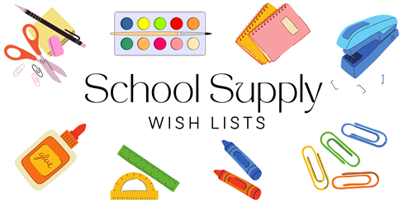

**4TH GRADE**

**24/25**

3 PLASTIC POCKET FOLDERS WITH PRONGS (assorted colors)

4 WIDE RULED COMPOSITION NOTEBOOKS (any colors)

48 #2 TICONDEROGA PENCILS (SHARPENED)

5 LARGE ELMER GLUE STICKS

1 BOX OF CRAYOLA CRAYONS – 24ct

1 BOX OF COLORED PENCILS - 24ct

1 PAIR OF CRAYOLA MARKERS - 8ct

1 PAIR OVER THE HEAD HEADPHONES OR EARBUDS

1 RECORDER FOR MUSIC CLASS

3 SPIRAL NOTEBOOK COLLEGE-RULED SINGLE SUBJECT

2 LANYARDS WITH ID HOLDERS

2 REAMS COPY PAPER

1 JUMBO CLOROX WIPES

2 BLACK SHARPIES (REGULAR SIZE)

1 PACK BLACK EXPO MARKERS

2 YELLOW HIGHLIGHTERS

1 PAIR OF STUDENT SCISSORS

1 SELF-CONTAINED PENCIL SHARPENER

1 PENCIL POUCH

**GIRLS ONLY:**

1 BOX KLEENEX TISSUES (110ct)

1 CAN LYSOL SPRAY

1 BOX QUART SIZE ZIPLOC BAGS

**BOYS ONLY:**

1 ROLL OF PAPER TOWELS

1 MAGIC ERASER

1 BOX GALLON SIZE ZIPLOC BAGS